SIMATS ENGINEERING
ASSESSMENT TOOL 1

COURSE NAME: COMPUTER NETWORKS COURSE CODE: CSA07

COURSE OUTCOME COVERED
CO5:
Design network topologies star, mesh, bus, and hybrid using networking devices, transmission media, and cabling standards
(BL2,BL5)
Assessment Tool Weightage: 40%

QUESTIONS: 3 Total Marks:30
Annexure A
Constraint-Based Problem Solving

Code of Conduct:
I M.Greeshma/_192524195 (Name / Reg No) certify that this submission is my original work
and that I have adhered to the guidelines specified for this assessment.
I understand that any violation of academic integrity rules will result in disciplinary action.

Signature of the student:M.Greeshma

Constraint-Based Problem Solving

1. A multinational company is opening a new branch office in a remote
rural location where high-speed wired internet is unavailable. The office
must support cloud-based applications, video conferencing, and secure
communication with the headquarters. The company has a limited budget
for connectivity but requires uninterrupted business operations. As a
network engineer, recommend a suitable internet connection, networking
devices, and security mechanisms. Justify your recommendations by
considering bandwidth limitations, reliability, cost, and future scalability

sol :
Recommended Internet Connection
- Primary: Satellite broadband (Starlink or similar)
  - Speeds: 50–250 Mbps, sufficient for cloud apps and HD video conferencing.
  - Coverage: Available in most rural areas where fiber/cable is absent.
  - Cost: Around ₹8,000–₹10,000/month in India, lower than leased lines.
  - Reliability: Weather can affect performance, but modern systems have improved stability.
- Backup: 4G/5G Fixed Wireless
  - Uses SIM-enabled routers or hotspots.
  - Provides redundancy during satellite outages.
  - Cost-effective, widely available in rural India.
  - Best providers: Airtel, Jio, and BSNL for rural coverage.
🖥️ Networking Devices
- Business-grade router with dual-WAN support
  - Allows automatic failover between satellite and 4G/5G.
  - Example: Cisco Meraki MX series, Ubiquiti EdgeRouter.
- Enterprise Wi-Fi access points
  - Ensure strong coverage across office floors.
  - Example: Aruba Instant On, TP-Link Omada.
- Firewall & VPN appliances
  - Secure communication with headquarters.
  - Example: Fortinet FortiGate, Sophos XG.
🔒 Security Mechanisms
- VPN (IPSec/SSL): Encrypts traffic between branch and HQ.
- Next-Gen Firewall: Protects against malware, phishing, and unauthorized access.
- Regular patching & endpoint security: Ensures devices remain secure.
- Multi-factor authentication (MFA): Adds extra protection for cloud apps.
📊 Evaluation Table
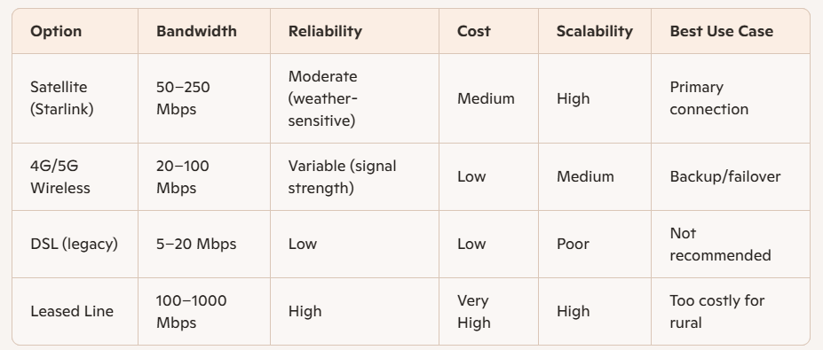
Risks & Trade-offs
- Satellite latency (~40–60 ms): Acceptable for video calls but not ideal for real-time trading or gaming.
- 4G/5G congestion: Speeds may drop during peak hours.
- Cost vs. reliability: Leased lines are more reliable but unaffordable in rural setups.
- Scalability: Satellite + wireless hybrid can scale with additional bandwidth packages.

2. A university plans to provide campus-wide wireless internet access for
more than 3,000 students across classrooms, laboratories, libraries, and
hostels. The network must support a large number of simultaneous users
while minimizing signal interference and ensuring secure access. Due to
budget constraints, only a limited number of wireless access points can be
deployed. Analyze the requirements and propose an efficient wireless
network design, including access point placement, frequency band
selection, and authentication methods. Explain how your solution
balances coverage, performance, security, and cost.

Sol:
📡 Access Point Placement
- Strategic High-Density Zones:
  - Classrooms, libraries, and hostels need the highest density.
  - Place APs in ceilings or central corridors to maximize coverage.
  - Use sectorized antennas in large halls to split coverage areas.
- Coverage Optimization:
  - Conduct a site survey to identify interference sources (walls, labs with equipment).
  - Deploy APs in a hexagonal grid pattern to minimize overlap and dead zones.
  - Limit AP count by maximizing coverage radius (enterprise APs can cover ~30–50m indoors).
📶 Frequency Band Selection
- Dual-Band (2.4 GHz + 5 GHz):
  - 2.4 GHz → Better range, fewer APs needed, but prone to interference.
  - 5 GHz → Higher throughput, less interference, ideal for classrooms and labs.
- Band Steering:
  - Push capable devices to 5 GHz to reduce congestion on 2.4 GHz.
  - Reserve 2.4 GHz for older devices and IoT.
- Channel Planning:
  - Use non-overlapping channels (1, 6, 11 for 2.4 GHz).
  - Dynamic channel assignment for 5 GHz to minimize interference.
🔒 Authentication & Security
- 802.1X with RADIUS Authentication:
  - Provides secure, per-user access.
  - Integrates with student credentials (university LDAP/Active Directory).
- WPA3-Enterprise:
  - Strong encryption, prevents password sharing.
- Network Segmentation:
  - VLANs for students, faculty, guests, and IoT devices.
  - Guest Wi-Fi with captive portal and bandwidth limits.
- Access Control:
  - MAC filtering for lab equipment.
  - Firewalls to block malicious traffic.
📊 Balancing Coverage, Performance, Security, and Cost
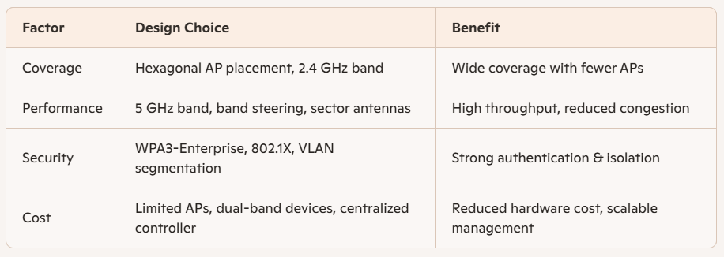

3. A financial institution is upgrading its internal computer network to
improve cybersecurity while allowing employees to access sensitive
customer information and online banking services. The organization must
comply with strict security policies without significantly affecting
network performance or increasing operational costs. Design a secure
network architecture by selecting appropriate network segmentation
techniques, firewall deployment, authentication methods, and intrusion
detection mechanisms. Justify your design by considering the constraints
of security, performance, compliance, and budget.

Sol:
🏦 Network Segmentation
- Core Principle: Zero Trust + Segmentation
  - Internal Segmentation:
    - Separate VLANs for customer data, employee workstations, servers, and guest devices.
    - Critical banking applications isolated in a secure zone with restricted access.
  - DMZ (Demilitarized Zone):
    - Hosts web servers, online banking portals, and email gateways.
    - Segregated from internal systems to reduce exposure.
  - Micro-Segmentation (optional, scalable):
    - Use software-defined networking (SDN) or firewalls at the VM level for granular control.
🔥 Firewall Deployment
- Next-Generation Firewalls (NGFW):
  - Deploy at perimeter (internet-facing) and internal boundaries (between VLANs).
  - Features: Deep packet inspection, application control, intrusion prevention.
  - Example: Fortinet FortiGate, Palo Alto Networks, Cisco ASA with FirePOWER.
- Policy Enforcement:
  - Strict rules for sensitive zones (customer data, transaction servers).
  - Allow only necessary protocols (HTTPS, secure APIs).
  - Block peer-to-peer, unauthorized cloud storage, and risky applications.
🔑 Authentication Methods
- Multi-Factor Authentication (MFA):
  - Required for all employees accessing sensitive systems.
  - Combine passwords with tokens, biometrics, or mobile apps.
- Role-Based Access Control (RBAC):
  - Employees only access data relevant to their role.
  - Prevents privilege creep and insider threats.
- Single Sign-On (SSO) with 802.1X:
  - Centralized identity management via Active Directory/LDAP.
  - Ensures secure Wi-Fi and wired access.
🛡️ Intrusion Detection & Monitoring
- Intrusion Detection/Prevention Systems (IDS/IPS):
  - Deploy inline with firewalls to detect anomalies.
  - Signature-based + behavior-based detection.
  - Example: Snort, Suricata, Cisco FirePOWER.
- Security Information and Event Management (SIEM):
  - Collect logs from firewalls, servers, and endpoints.
  - Real-time correlation for compliance reporting (PCI DSS, ISO 27001).
  - Cost-effective options: Splunk, Elastic SIEM, Microsoft Sentinel.
- Endpoint Detection & Response (EDR):
  - Lightweight agents on employee devices.
  - Detect ransomware, phishing, and insider threats.

📊 Balancing Security, Performance, Compliance, and Cost
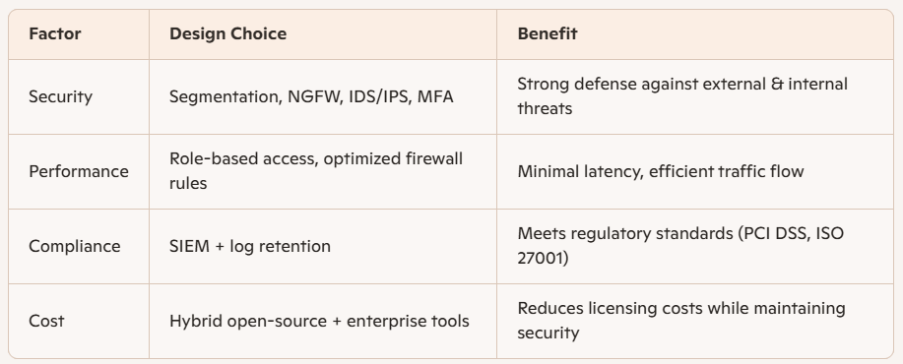

Final Recommendation
- Segment the network into secure zones with VLANs and DMZ.
- Deploy NGFWs at perimeter and internal boundaries for layered defense.
- Enforce MFA + RBAC + SSO for secure employee access.
- Implement IDS/IPS + SIEM monitoring for real-time threat detection and compliance.
- Use a hybrid approach (enterprise firewalls + open-source IDS/IPS) to balance cost and performance.

